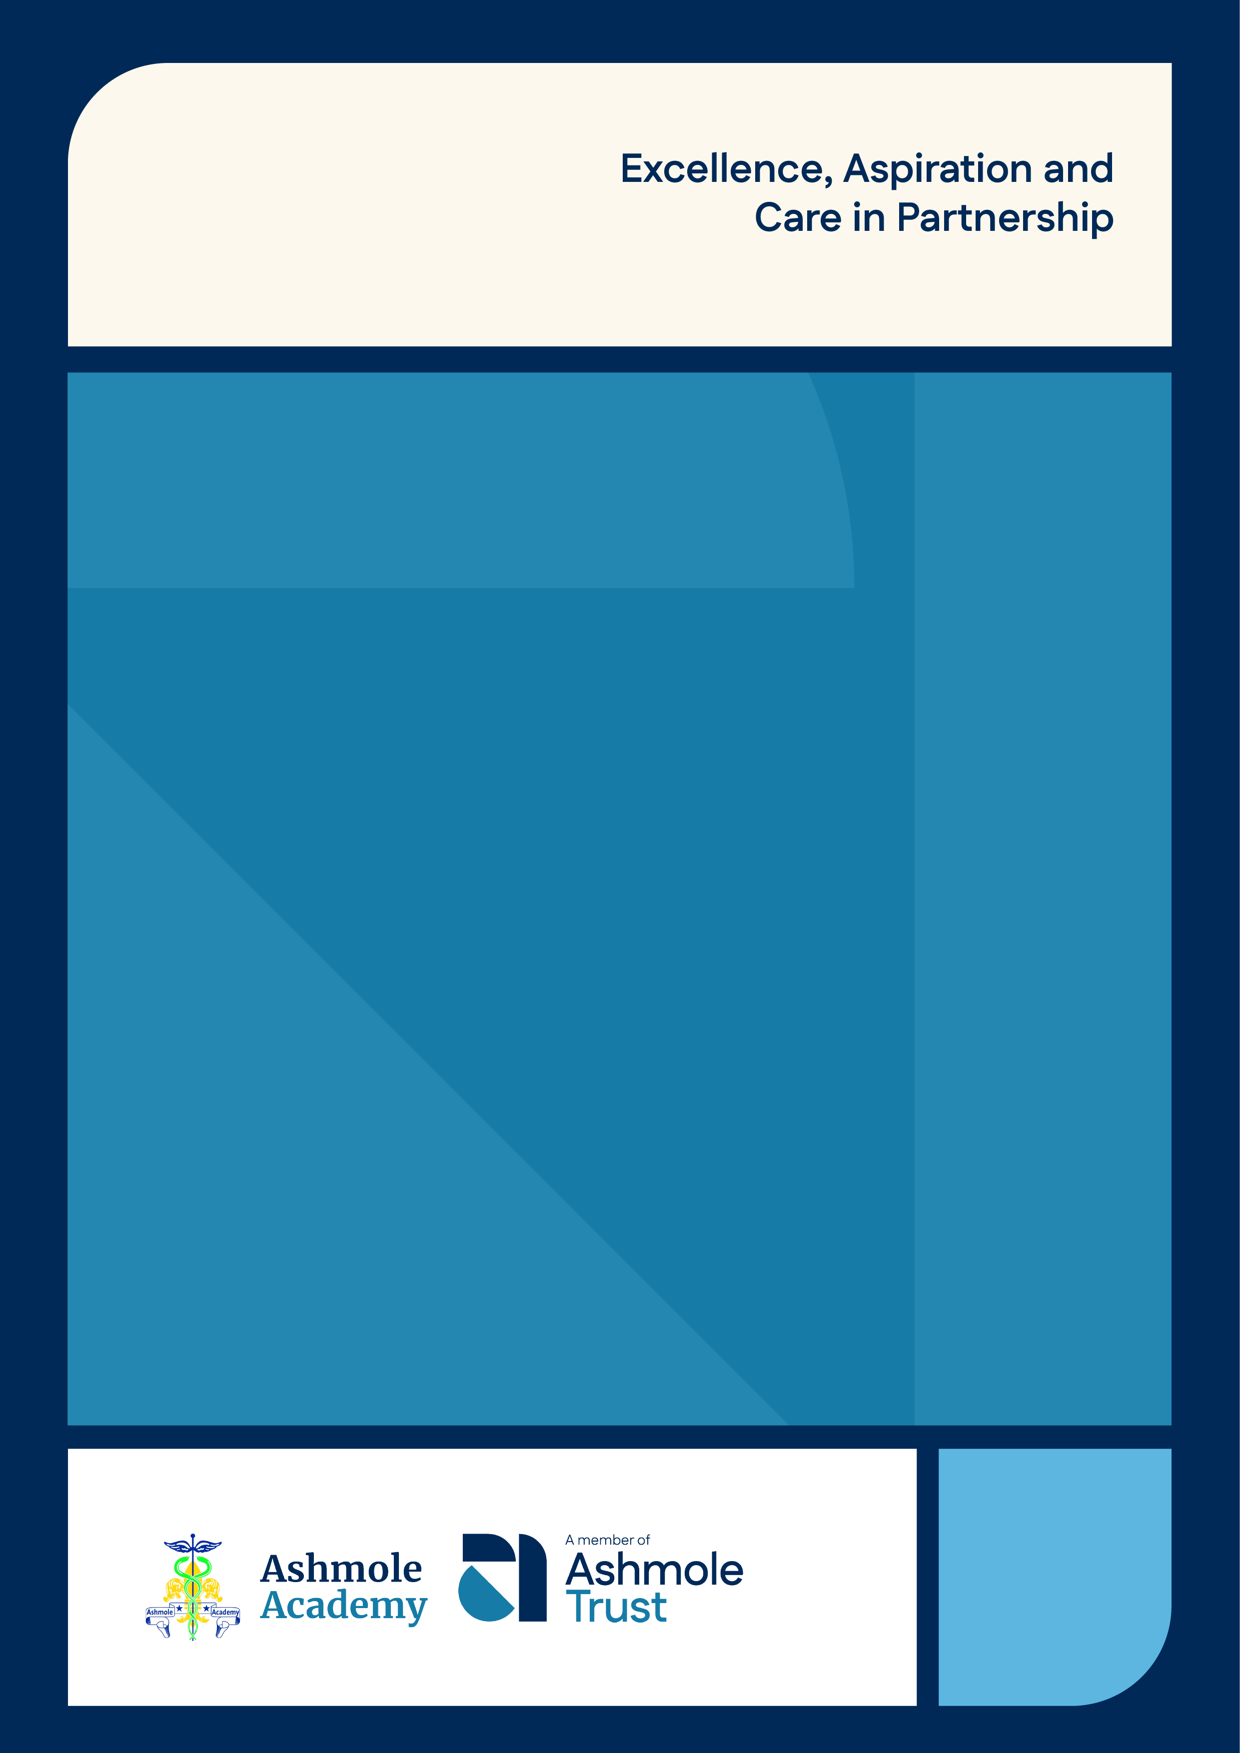
Careers Policy

2025.26



Written by | Mrs Brown
Approved by | Mr Balbinder Dhinsa
Signed | 
Date approved | September 2025
Next review date | September 2026

Careers Guidance:
Details of the Careers Programme and Provider Access Arrangements and Legislation

Introduction
- Aims

Objectives
- Commitment

Implementation
- Impact
- Monitoring and Review

External partnerships
- Links with other policies

Website Information

Provider Access Legislation (PAL) – Policy Statement

Introduction:

Ashmole Academy is committed to providing a high-quality programme of Careers Education, Information, Advice and Guidance (CEIAG) for all students, in line with national statutory requirements and best practice.

We recognise that all young people need a planned, progressive programme of careers activities to help them make informed choices at key transition points (including 14–19), succeed in education and training, and enter the world of work as confident, capable individuals.

Our careers provision is structured around the Gatsby Benchmarks, which we use as a framework to evaluate and continuously improve the programme. We also meet the statutory requirements set out in the Department for Education’s Careers Guidance and Access for Education and Training Providers (DfE, updated May 2025).
Further information on the Gatsby Benchmarks can be found here:

https://www.gatsby.org.uk/education/focus-areas/good-career-guidance

Aims:

The Careers Education, Information, Advice and Guidance (CEIAG) programme at Ashmole Academy aims to
support all students in developing the knowledge, skills, and experiences needed to make informed decisions
about their futures and to manage their careers effectively throughout their lives.
Our CEIAG provision aims to promote:

- Self-development:
Students will develop self-awareness by assessing their strengths, interests, and values. They will reflect on these to inform their future learning, work choices, and to build self-confidence and resilience. Students will also understand the influences on their decisions, including personal, social, and economic factors.
- Career exploration:
Students will explore a wide range of career and education pathways through: careers web-based platforms (e.g. Unifrog), career-focused curriculum days, careers fairs and assemblies, talks and webinars from universities, apprenticeship providers, employers, alumni, and technical/vocational education representatives and opportunities to meet with an impartial and qualified Careers Adviser
- Experience of the workplace
All students will have opportunities to experience the workplace, enabling them to develop an understanding of real working environments, job roles, and employability skills.
- Careers education in the curriculum
Students will access high-quality careers education through personal development lessons, assemblies, the PSHE curriculum and across subject areas. This includes learning about: labour market information (LMI), post-16 and post-18 options (including technical education, apprenticeships, and university), workers’ rights and responsibilities, entrepreneurship and enterprise
- Equal access and inclusion
We are committed to ensuring that all students, regardless of background or ability, have access to personalised support and meaningful encounters with a range of education and training providers, in line with current provider access legislation.

Objectives:

The CEIAG programme at Ashmole Academy is designed to meet the needs of all students by providing a personalised and progressive pathway through career-related learning. Activities are tailored to each student’s stage of development, and the programme evolves across Key Stages 3, 4 and 5.
The primary objectives of the CEIAG programme are to:
- Prepare students for the opportunities, responsibilities, and experiences of adult life — with a particular focus on their future careers.
- Enable students to develop an accurate understanding of their strengths, skills, interests, values, and the ways these relate to their personal and professional development.
- Support students in exploring a wide range of opportunities for further learning, training, and employment — including academic, technical, and vocational routes.
- Guide students through key transition points, helping them to make informed decisions at 14, 16, and 18.
- Ensure that all students are supported to progress to sustained destinations in education, employment, or training.
Additionally, the programme seeks to:
- Raise aspirations, increase motivation, and contribute to improved educational outcomes.
- Promote equality of opportunity by challenging stereotypes and ensuring inclusive access to all pathways.
- Encourage participation in education and training beyond the age of 16 and 18.
- Develop key employability and enterprise skills that are valued by employers.
- Contribute to the personal development and economic well-being of students and their communities.
The CEIAG programme offers a broad range of meaningful experiences — including employer encounters, workplace experiences, and independent guidance — to support students in making confident, well-informed career decisions

Commitment:
Ashmole Academy is committed to delivering a high-quality career education, information, advice and guidance (CEIAG) programme that empowers all students to manage their career development and sustain employability throughout their lives. This commitment is inclusive of all learners, regardless of background, ability, or personal circumstance.
Our careers programme is shaped by key national frameworks and policies, including the Gatsby Benchmarks, the Careers Development Institute (CDI) Framework, and the DfE Statutory Careers Guidance (2025). A full list of guiding documents can be found in Annex 1.
We recognise that effective CEIAG contributes significantly to the personal, social, and academic development of students. It prepares them for the complexities of a rapidly changing world, where education, training, and employment pathways are increasingly diverse and flexible.
To ensure our CEIAG programme is inclusive, effective, and continually improving, we:
- Work in close partnership with a qualified, independent external careers adviser, providing appropriate facilities and student information to support personalised and impartial guidance.
- Ensure students have access to accurate and impartial information on education and training options, career pathways, and labour market trends.
- Deliver a planned, progressive programme of CEIAG from Years 7 to 13, embedded within the curriculum and supplemented through assemblies, events, trips, and targeted guidance.
- Fully comply with Provider Access Legislation, ensuring students have multiple opportunities to hear from a range of providers of technical education, apprenticeships, and other post-16 and post-18 pathways.

5. Implementation
The CEIAG programme at Ashmole Academy is delivered through a coordinated and embedded approach. It is implemented via:
- The PSHE curriculum (including careers education topics)
- Personal development and mentoring sessions
- Opportunities for individual careers interviews with a qualified external adviser
- Career-focused days and timetabled events across the key stages
- Careers talks, assemblies, webinars, and presentations from a wide range of providers and employers
- The work experience programme
- The use of Unifrog, our online careers platform, which all students can access from Year 7 to Year 13

Leadership and Coordination
- The Careers Lead oversees the planning, delivery, and evaluation of the programme and is accountable to the leadership team
- The Careers Lead also supervises the Careers Co-Ordinator, who provides logistical and administrative support.
- The Careers Co-ordinator works closely with the external Careers Adviser, who provides impartial guidance and supports the statutory requirement for independent careers advice.

Whole-School Contribution
- All staff contribute to the careers programme through their roles as subject teachers, tutors, or event leaders.
- PSHE teaching staff and personal tutors deliver specialist lessons focused on careers and employability skills.
- The programme is enhanced through cross-curricular links.

Targeted Support
- Vulnerable students, including those with SEND or identified by the SENCO or pastoral teams, receive enhanced CEIAG support, including guaranteed individual interviews with an external adviser.
- Transition guidance is prioritised at key decision points in Years 9, 11, and 13, and includes:
  - Mentoring
  - Online research
  - Subject-specific advice
  - Parental involvement

Access to Resources
Students have access to a range of resources, including:
- Opportunities and guidance through Google Classroom
- Regular updates and adverts in the Ashmole Round-Up
- The school website
- Individual Unifrog profiles, enabling research, planning, and reflection on pathways

Careers Learning Outcomes by Key Stage

By the end of Key Stage 3, students:
- Can identify their strengths, skills, and personal qualities
- Understand the link between subjects and career pathways
- Are aware of the KS4 options and their implications
- Engage in career exploration through Unifrog
- Discuss choices confidently with their personal tutors and parents/carers

By the end of Key Stage 4, students:
- Can research and evaluate a range of post-16 pathways
- Understand the pros and cons of vocational, technical, and academic routes
- Know how to access further careers information
- Reflect on their work experience and how it builds employability
- Use Unifrog to build a post-16 plan and support decision-making

By the end of Key Stage 5, students:
- Are fully prepared for next steps in education, employment, or training
- Can complete UCAS applications and prepare for interviews confidently
- Understand alternative options such as apprenticeships or degree apprenticeships
- Can articulate strengths, skills, and areas for development
- Use Unifrog effectively to manage applications and career planning

Impact:

The impact of Ashmole Academy’s CEIAG programme is evaluated regularly to ensure it meets the needs of all students and enables continuous improvement. Multiple sources of data and feedback are used to assess how well the programme supports students in making informed and ambitious career choices.

1. Destination Data
- Post-16 and Post-18 destination data is collected annually and analysed at the start of each academic year.
- This data is used to:
  - Identify trends and gaps in progression
  - Support planning of targeted interventions
  - Inform curriculum and event planning
  - Ensure students are progressing into sustained education, training or employment

2. Student Feedback and Evaluations
- Students complete evaluations following:
  - Major careers events
  - Work experience placements
  - Careers-focused lessons
- Feedback is used to assess:
  - Change in knowledge and confidence after events
  - Relevance and quality of information provided
  - Student satisfaction and suggestions for improvement

3. Observations and Learning Walks
- The Careers Lead and other senior leaders conduct learning walks and observations of:
  - PSHE careers lessons
  - Personal Development lessons with personal tutors
  - Careers-focused events
- Observations assess the quality and consistency of delivery and student engagement.

4. Student Voice
- Students contribute to the development of the programme through:
  - The Student Voice Committees
  - Online feedback platforms (e.g. via Google Classroom)
  - Focus groups or surveys around CEIAG events and provision
- Feedback is used to co-create a programme that reflects students’ needs and aspirations.

5. External Feedback
We regularly seek input from our external Careers Adviser to review and discuss the effectiveness of our CEIAG (Careers Education, Information, Advice and Guidance) programme. The school also uses the Compass+ tool to evaluate provision against the Gatsby Benchmarks and identify areas for development.
In addition, we work in partnership with the West London Careers Hub, which provides further guidance, support, and external validation of our career’s activities. Feedback is also gathered from employers and other external partners following careers events, work experience placements, and workshops to inform continuous improvement.

  - Monitoring and Review
The CEIAG programme and careers policy are reviewed annually to ensure they remain effective, compliant with statutory requirements, and responsive to student needs.

Monitoring
- The Careers Lead monitors:
  - Programme delivery across PSHE, tutor time, and curriculum areas
  - Quality of external provision, including employer encounters and adviser sessions
  - Student engagement with platforms such as Unifrog
- Monitoring tools include:
  - Student feedback
  - Learning walks
  - Staff evaluations
  - Event analysis and participation rates

Review
- An annual review is conducted in consultation with:
  - Teaching staff
  - Students and parents
  - Governors and SLT
  - The external careers adviser and relevant external partners
- Key data sources used:
  - Destination data (KS4 and KS5)
  - Evaluation feedback from careers activities and events
  - National and local policy updates
- The outcomes inform future planning, ensure statutory compliance, and improve CEIAG delivery and student outcomes.

Staff Development
- Staff delivering or supporting CEIAG are offered ongoing CPD
- This includes updates on:
  - Labour market trends
  - Technical education and apprenticeship routes
  - Careers software (e.g., Unifrog)
  - Gatsby Benchmark best practice
  - Mentoring

  - External Partnerships
Ashmole Academy recognises the value of working closely with a wide range of external partners to enhance the quality and breadth of its careers education, advice and guidance programme.

Careers Adviser Partnership
A partnership with our independent, Level 6-qualified careers adviser, setting out their role in delivering impartial one-to-one and group guidance, supporting transition planning, and contributing to strategic careers planning.

Employer and Provider Engagement
We work in collaboration with a range of external organisations to deliver high-quality career-related learning experiences. These include: Inspiring the Future, ASK Apprenticeships, Young Professionals, Local employers and businesses from various sectors and Colleges, sixth forms, training providers and universities
These partnerships provide opportunities for employer talks and workplace visits, work experience placements (Years 10 and 12), apprenticeship workshops and skills development, careers fairs and mock interviews and information on technical, vocational and academic pathways

Provider Access Legislation
In accordance with the Provider Access Legislation (PAL), Ashmole Academy ensures that all students in Years 8 to 13 have access to at least six provider encounters during their time at school. These encounters are with approved providers of apprenticeships, technical education and other post-14, post-16 and post-18 options.
We are committed to continually expanding our network of employer and provider partners to ensure all students receive meaningful encounters and real-world insight into future career options.

Links with other policies:

The CEIAG policy is supported by and contributes to a range of school policies, including those for:
- Teaching and Learning
- Assessment, Recording and Reporting
- PSHE and Citizenship
- Equal Opportunities and Diversity
- Special Educational Needs and Disabilities (SEND)
- Looked After Children
These policies work together to ensure inclusive, effective, and high-quality provision for all students.

Website Information

Ashmole Academy’s Careers Page includes all statutory information required by the Department for Education. This includes:
- The name, email address and telephone number of the Careers Lead
- A summary of the careers programme
- Details of how students, parents, carers, staff and employers can access information about the programme
- Information on how the school measures and assesses the impact of its careers provision
- The date of the next review of the published careers information
- The school’s provider access arrangements, in line with the Baker Clause and Provider Access Legislation
This information is reviewed and updated annually to ensure accuracy, transparency and statutory compliance.

    - Provider Access Legislation (PAL) – Policy Statement

This policy statement sets out the school’s arrangements for managing the access of providers to pupils at the school for the purpose of giving them information about the provider’s education or training offer.
This complies with the school’s legal obligations under Section 42B of the Education Act 1997, updated September 2022. Ashmole endeavours to ensure that all students are aware of all routes to higher skills and are able to access information on technical options and apprenticeships (The Department of Education, July 2021: “Baker Clause”: supporting students to understand the full range of education and training options, and the Provider Access Legislation, January 2023, updated May 2025)

Pupil entitlement:
All pupils in Years 7-13 are entitled:

- To find out about technical education qualifications and apprenticeships opportunities, as part of a careers programme which provides information on the full range of education and training options available at each transition point
- To hear from a range of local providers about the opportunities they offer, including technical education and apprenticeships – through options events, assemblies and group discussions and taster events
- To understand how to make applications for the full range of academic and technical courses. A number of events throughout the school year will offer providers an opportunity to speak to parents/carers and students about their careers and pathways, for examples assemblies and Information evenings. Information about these events can be found on the school’s website.

Access arrangements for provider for premises and facilities:
External agencies will be provided with suitable and appropriate facilities including access to required IT equipment, guest Wi-Fi access, rooms, required furniture and a break out room. Any special requirements for the delivery of the careers provision must be requested at least 7 days in advance.
All requests should be emailed at least a month in advance of an expected date for the planned session. All requests will be given due consideration from the Careers Lead and Senior Leadership. Requests may be refused if:
  - they impinge on students’ preparation for public or internal exams
  - they clash with other planned school events
  - the school is unable to provide staff to support the event
  - rooming is unable to be found due to timetabling clashes A provider wishing to request access should contact:

Mr Louca, Lead for Careers Provision mlo@ashmoleacademy.org Tel: 0208 361 2703 ext.: 2221

All visitors to site will be required to read our safeguarding policy upon registering at reception and will be required to adhere to all safeguarding policy and procedures whilst on school.

Schools and colleges have a responsibility to set students on the path that will secure the best outcome which will enable them to progress in education and work and give employers the highly skilled people they need.
That means schools and colleges must act impartially, in line with their statutory duty or contractual requirement, and not show bias towards any route, be that academic or technical. We promote a full range of technical options.

The updated provider access legislation (PAL, May 2025) specifies schools must provide at least six encounters for all their students:

  - Two encounters for pupils during the ‘first key phase’ (year 8 or 9) that are mandatory for all pupils to attend
  - Two encounters for pupils during the ‘second key phase’ (year 10 or 11) that are mandatory for all pupils to attend
  - Two encounters for pupils during the ‘third key phase’ (year 12 or 13) that are mandatory for the school to put on, but optional for pupils to attend

The new legislation will become a key mechanism to further help learners understand and take-up, not just apprenticeships, but wider technical education options such as T-Levels and Higher Technical Qualifications.

These provider encounters will be scheduled during the main school hours and the provider will be given a reasonable amount of time to, as a minimum:

  - Share information about both the provider and the approved technical education qualifications and apprenticeships that the provider offers
  - Explain what career options for these routes could lead to
  - Provide insights into what it might be like to learn or train with that provider (including the opportunity to meet staff and pupils from the provider)
  - Answer questions from pupils about the provider or approved technical educational qualifications and apprenticeships

Encounters will take part of the normal hours of the school day that is from 8.40am – 3.20pm.

As part of our careers programme, we will consider requests from approved training, apprenticeship, technical and vocational education providers to speak to our students. In addition, Ashmole Academy will approach these providers directly in order to plan and organise these encounters. These may be in the form of school assemblies, webinars, parents evenings and careers engagements events.

As well as requests, a number of events that are integrated into the careers programme at Ashmole Academy will offer students meaningful encounters with approved training, apprenticeship, technical and vocational education providers which meet the requirements of the Provider Access Legislation (2025). Further details of this will be available on our website.

All requests made by providers should be made at least a month in advance of the expected session. Requests by providers should be sent to Mr Louca:

Mr Louca, Lead for Careers Provision mlo@ashmoleacademy.org Tel: 0208 361 2703 ext.: 2221

Please complete the table below and forward it in an email to Mr Louca:

Name of provider
Contact name and details
Proposed date, time and length of session
Aims and objectives of the session including the year group
Proposed format, timings and duration of the session. Will equipment be required?
Supported required from Ashmole Academy
Do any of the Gatsby benchmarks relate to the session and if so, how?

Annex 1:

- Education Act 2011, Section 19
- The Technical and Further Education Act 2017
- DfE Careers Strategy (December 2017)
- Careers Guidance and Access for Education and Training Providers – Statutory Guidance (DfE, updated May 2025)
- Provider Access Legislation (PAL) (effective January 2023 and updated May 2025)
- Ofsted Education Inspection Framework (EIF)
- Career Development Institute (CDI) Framework for Careers
- Employability and Enterprise Education (2023)
- Gatsby Benchmarks for Good Career Guidance (Updated 2025)
- SEND Code of Practice (2015)

